Vincent Ryan

7/7/2024

Module 7 - Python SQL 1

Printouts for this assignment:

Code:

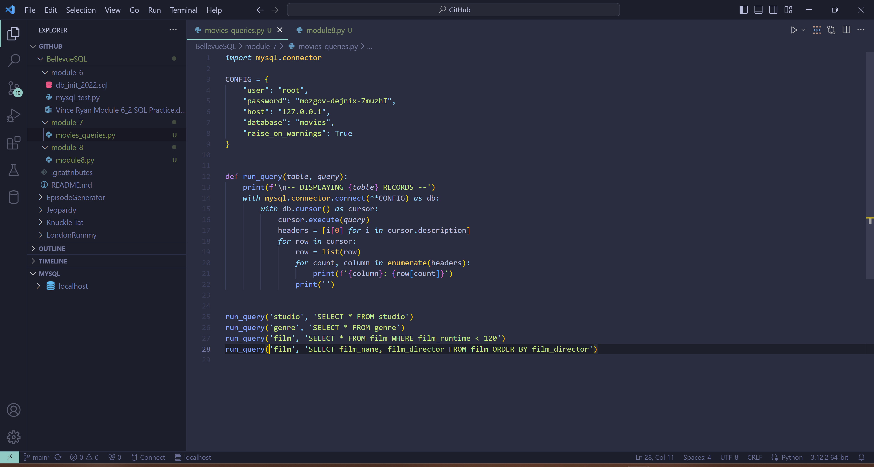

Printouts

